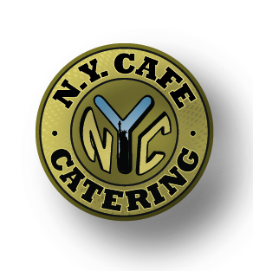 This Week’s Specials:
October 19th – October 23rd

Biscuits & Gravy $3.50
Breakfast Bowl $4.99
Two Scrambled Eggs, Potatoes, Cheese & Your Choice of Bacon, Sausage or Ham
ADD SAUSAGE GRAVY $1.50

Monday (8:00am – 2:00pm)
Special #1 French Dip $9.99
Oven Roasted Beef, Provolone & Whipped Horseradish
Served with Au Jus, Pasta Salad & a Soda
Special #2 Chicken Salad Croissant $8.99
Topped with Lettuce & Tomato
Served with Pasta Salad & a Soda
Tuesday (8:00am – 3:00pm)
Special #1 Pastrami Rueben $9.99
Pastrami, Swiss, Thousand Island & Sauerkraut
On Rye Served with Potato Salad & a Soda
Special #2 Chicken Steak $9.99
With Your Choice of Toppings
Served with Potato Salad & a Soda

Wednesday (8:00am – 3:00pm)
Special #1 Lomo Platter $9.99
Lomo Saltado Served with
Rice & a Side Salad
Special #2 Fried Chicken Wrap $9.99
Fried Chicken Chunks, Lettuce, Tomato, Cheese &
Ranch in a Tortilla Served with Pasta Salad & a Soda
Thursday (8:00am – 3:00pm)
Special #1 Cuban Sandwich $9.99
Thinly Sliced Pork & Ham, Swiss, Pickles & a Mojito Spread
Grilled Served with Potato Salad & a Soda
Special #2 Turkey Club $9.99
Turkey, Lettuce, Tomato, Bacon & Mayo on
White or Wheat Served with Potato Salad & a Soda
Friday (8:00am – 2:00pm)
Special #1 Chili Burger $9.99
Angus Burger Topped with Chili, Cheese & Onions
Served with Pasta Salad & a Soda
Special #2 Hot Ham & Cheese $9.99
Grilled Ham, Lettuce, Tomato, Cheese & Honey Mustard
Served with Pasta Salad & a Soda

