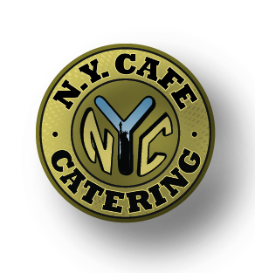 This Week’s Specials:
August 3rd – August 7th

Pancake Platter $4.99
Two Fluffy Pancakes Served with Your Choice of Bacon, Sausage or Ham

Monday (8:00am – 2:00pm)
Special #1 Hot Ham & Cheese $9.99
Grilled Ham, Lettuce, Tomato, Cheese & Honey
Mustard Served with Potato Salad & a Soda
Special #2 New Yorker $9.99
Corned Beef, Swiss, Thousand Island & Coleslaw
On Rye Served with Potato Salad & a Soda
Tuesday (8:00am – 3:00pm)
Special #1 Taco Combo $9.99
Two Soft Tacos (Chicken or Beef) Topped
With Lettuce, Tomato, Cheese & Salsa
Served with Spanish Rice & a Soda
Special #2 Italian Hero Combo $9.99
Salami, Ham, Provolone, Lettuce, Tomato, Onion, Pickles &
Italian Dressing Served with Pasta Salad & a Soda

Wednesday (8:00am – 3:00pm)
Special #1 Lomo Platter $9.99
Lomo Saltado Served with
Rice & a Side Salad
Special #2 Fried Chicken Wrap $9.99
Chicken Bites, Lettuce, Tomato, Cheese
& Ranch in a Tortilla Served with Potato Salad & a Soda
Thursday (8:00am – 3:00pm)
Special #1 Nachos $8.99
Homemade Tortilla Chips Topped with (Chicken or Beef),
Queso, Beans, Lettuce, Tomato, Jalapeno, Salsa &
Sour Cream Served with a Soda
Special #2 Club Sandwich $9.99
Ham, Turkey, Lettuce, Tomato, Bacon & Mayo
on White or Wheat Served with Pasta Salad & a Soda
Friday (8:00am – 2:00pm)
Special #1 Southwest Burger $9.99
Angus Burger Topped with Lettuce, Tomato, Pepper Jack,
Jalapenos & Salsa Served with Potato Salad & a Soda
Special #2 Buffalo Chicken Sandwich $9.99
Chicken Breast Tossed in Buffalo Sauce, Lettuce, Tomato, Cheese &
Your Choice of Blue Cheese or Ranch Served with Potato Salad & a Soda

